**What is Motivation?**

* **Definition:** Motivation is the process by which a person’s efforts are energized, directed, and sustained towards attaining a goal. It is not a personal trait but a result of interactions between people and situations.
* **Components:**
  + **Energy:** The intensity or drive that propels an individual towards a goal.
  + **Direction:** The focus of efforts towards achieving organizational goals.
  + **Persistence:** The sustained effort to overcome obstacles and achieve goals.
* **Effectiveness:** Motivation works best when individual needs align with organizational goals.

**Example:**

* **Training for a 5K Race:**
  + **Energy:** The individual is excited and dedicates time to train, driven by the desire to improve fitness.
  + **Direction:** The goal is to complete the 5K in under 30 minutes.
  + **Persistence:** Despite challenges like fatigue and bad weather, the individual sticks to the training plan, adjusting as necessary.

**Early Theories of Motivation**

**1. Maslow's Hierarchy of Needs**

* **Levels of Needs:**
  + **Physiological Needs:** Basic needs like air, food, water, and shelter.
  + **Safety Needs:** Protection from harm, security, and well-being.
  + **Love and Belongingness Needs:** Desire for interpersonal relationships and social connections.
  + **Esteem Needs:** Desire for self-respect, achievement, and recognition from others.
  + **Self-Actualization Needs:** Desire to realize personal potential and seek personal growth.

**Application in a Global E-commerce Company:**

* **Physiological Needs:** Provide a comfortable working environment, competitive salaries, and health benefits.
* **Safety Needs:** Ensure job security and adhere to health and safety regulations.
* **Social Needs:** Foster team-building activities and opportunities for networking.
* **Esteem Needs:** Offer recognition programs, professional development opportunities, and autonomy in work.
* **Self-Actualization:** Provide opportunities for creativity, personal growth programs, and challenging assignments.

**2. McGregor’s Theory X and Y**

* **Theory X (Authoritarian Style):**
  + Assumes employees dislike work and need to be controlled and directed.
  + Emphasizes external control and the threat of punishment to achieve goals.
* **Theory Y (Participative Style):**
  + Assumes employees are self-motivated and seek responsibility.
  + Encourages participation, creativity, and self-direction.

**3. Herzberg's Motivation-Hygiene Theory**

* **Hygiene Factors:** Extrinsic factors that can cause dissatisfaction if not met (e.g., salary, working conditions, company policies).
* **Motivators:** Intrinsic factors that lead to job satisfaction (e.g., achievement, recognition, responsibility).
* **Key Insight:** The absence of dissatisfaction does not imply satisfaction; both hygiene factors and motivators are necessary for motivation.

**Example:**

* An employee may have a good salary and safe working conditions (hygiene factors) but may not feel motivated if the job lacks challenges or opportunities for growth (motivators).

**Contemporary Theories of Motivation**

**1. Three-Needs Theory (McClelland)**

* **Need for Power (nPow):** Desire to control and influence others, often seen in leadership roles.
* **Need for Affiliation (nAffil):** Desire for social interaction and acceptance, important in team-oriented roles.
* **Need for Achievement (nAch):** Desire for personal accomplishment and excellence, often seen in individuals who seek challenging tasks and feedback.

**Example:**

* An employee with a high need for achievement might excel in roles that require setting and meeting challenging goals, such as sales or project management.

**2. Goal-Setting Theory**

* **Key Principles:**
  + Goals should be challenging and specific.
  + Commitment to goals is higher when they are self-set and aligned with personal values.
  + Feedback on progress is crucial for maintaining motivation.
  + Self-efficacy, or the belief in one's ability to achieve goals, enhances motivation.

**Example:**

* A sales team is more likely to be motivated if they set their own sales targets, receive regular feedback on their progress, and believe in their ability to meet those targets.

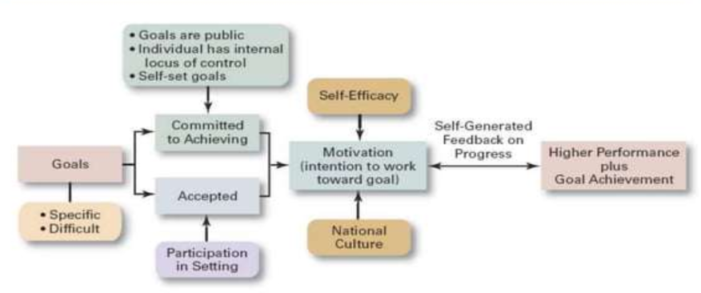

**3. Reinforcement Theory**

* **Principle:** Behavior is influenced by its consequences. Positive reinforcement encourages desired behaviors, while punishment discourages undesired behaviors.
* **Types of Reinforcement:**
  + **Positive Reinforcement:** Rewarding desired behavior to encourage its repetition.
  + **Negative Reinforcement:** Removing obstacles to encourage desired behavior.
  + **Punishment:** Decreasing undesired behavior through negative consequences.

**Example:**

* Praising an employee for completing a project early (positive reinforcement) encourages timely project completion in the future.

**4. Equity Theory**

* **Principle:** Employees compare their inputs (effort, skills) to outcomes (rewards, recognition) and seek fairness in this comparison.
* **Types of Justice:**
  + **Distributive Justice:** Fairness in the distribution of rewards.
  + **Procedural Justice:** Fairness in the processes that determine rewards.

**Example:**

* An employee may feel demotivated if they perceive a colleague receiving a higher salary for similar work, leading to feelings of inequity.

**5. Expectancy Theory**

* **Principle:** Motivation depends on the perceived likelihood that effort will lead to performance, which in turn leads to desired outcomes.
* **A diagram of a performance

  AI-generated content may be incorrect.Key Components:**
  + **Expectancy:** Belief that effort will lead to performance.
  + **Instrumentality:** Belief that performance will lead to rewards.
  + **Valence:** The value placed on the rewards.

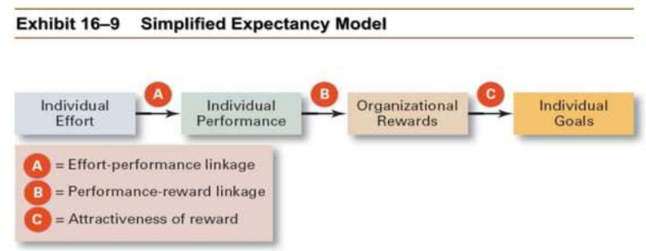

**Example:**

* A project manager is motivated to put extra effort into a project if they believe it will lead to successful completion (expectancy) and result in recognition or career advancement (valence).

**Current Issues in Motivation**

**1. Cross-Cultural Challenges**

* **Individualism vs. Collectivism:** Motivational programs must consider cultural differences in how rewards and recognition are perceived.
* **Uncertainty Avoidance:** Some cultures prioritize security and stability over risk-taking and innovation.

**2. Motivating a Diverse Workforce**

* **Flexibility:** Offering flexible work schedules and opportunities for learning and growth can motivate diverse employees.
* **Gender Differences:** Women may desire learning opportunities and flexible work schedules, while men may seek greater autonomy.

**3. Motivating Professionals**

* **Characteristics:** Professionals are often committed to their field, seek continuous learning, and value job challenges.
* **Motivators:** Providing challenging work, organizational support, and opportunities for professional growth.

**4. Motivating Contingent Workers**

* **Strategies:** Offering opportunities for permanent employment, training, and equitable compensation can motivate contingent workers.

**5. Motivating Low-Skilled, Minimum-Wage Employees**

* **Strategies:** Implementing employee recognition programs and providing sincere praise can enhance motivation.

**6. Designing Appropriate Reward Programs**

* **Open-Book Management:** Involving employees in decision-making by sharing financial information.
* **Employee Recognition Programs:** Providing personal attention and expressing appreciation for good work.
* **Pay-for-Performance:** Implementing variable compensation plans that reward employees based on performance.

**Scenario Based Questions**:

--

**Case Study 1: Implementing Motivational Strategies in a Tech Company**

**Case Description:**

A tech company, "TechInnovate," is experiencing low employee morale and high turnover rates. The management wants to implement strategies to motivate employees and improve retention. The company operates in a competitive industry with a need for continuous innovation.

**Question 1:**

How can TechInnovate use Maslow's Hierarchy of Needs to address employee morale and retention issues?

**Answer**:

TechInnovate can address employee needs as follows:

- Physiological Needs: Ensure competitive salaries and benefits that cover basic needs.

- Safety Needs: Provide job security and a safe working environment.

- Social Needs: Foster team-building activities and create opportunities for collaboration.

- Esteem Needs: Implement recognition programs and provide opportunities for career growth.

- Self-Actualization Needs: Offer challenging projects and support for personal and professional development.

**Question** **2:**

Which motivational theory would be most effective for encouraging innovation at TechInnovate? How can it be applied?

**Answer**:

The Expectancy Theory would be effective for encouraging innovation. TechInnovate can:

- Set Clear Goals: Establish challenging but achievable goals for innovation projects.

- Provide Feedback: Offer regular feedback on progress and outcomes to maintain motivation.

- Recognize Achievements: Reward employees for innovative ideas and successful project completion to reinforce desired behaviors.

---

**Case Study 2: Motivating a Diverse Workforce**

**Case Description:**

A multinational corporation, "GlobalCorp," has a diverse workforce with employees from various cultural backgrounds. The company is looking to implement motivational strategies that are effective across different cultures.

**Question 1:**

How can GlobalCorp address cross-cultural challenges in motivating its workforce?

**Answer**:

GlobalCorp can address cross-cultural challenges by:

- Understanding Cultural Differences: Recognize that motivational factors may vary across cultures (e.g., individualism vs. collectivism).

- Tailored Reward Systems: Design reward systems that align with cultural values, such as group-based rewards in collectivist cultures.

- Flexible Work Arrangements: Offer flexible work schedules and opportunities for professional development to accommodate diverse needs.

**Question** **2:**

How can the company apply Herzberg's Motivation-Hygiene Theory to motivate employees from different cultural backgrounds?

**Answer**:

GlobalCorp can apply Herzberg's theory by:

- Addressing Hygiene Factors: Ensure fair compensation, safe working conditions, and clear company policies to prevent dissatisfaction.

- Focusing on Motivators: Provide opportunities for achievement, recognition, and career growth, tailored to cultural preferences and values.

---

**Case Study 3: Motivating Employees in a Manufacturing Company**

**Case Description**:

A manufacturing company, "ManuFlex," is facing issues with employee engagement and productivity. The company operates in a stable market with routine production processes.

**Question 1:**

Which motivational theory would be most suitable for ManuFlex, and how can it be implemented?

**Answer:**

The Reinforcement Theory would be suitable for ManuFlex. The company can:

- Positive Reinforcement: Reward employees for meeting production targets and maintaining quality standards.

- Negative Reinforcement: Remove obstacles that hinder productivity, such as inefficient processes or equipment.

- Punishment: Implement consequences for consistent underperformance to discourage undesired behaviors.

**Question 2:**

How can ManuFlex use job design to enhance employee motivation and productivity?

**Answer:**

ManuFlex can use job design techniques such as:

- Job Enlargement: Expand the scope of jobs by adding variety to tasks, making them more interesting.

- Job Enrichment: Enhance jobs by adding responsibilities that require higher-level skills and decision-making, providing a sense of ownership and achievement.

---

**Case Study 4: Motivating Professionals in a Consulting Firm**

**Case Description:**

A consulting firm, "Strategic Solutions," employs professionals who often work on challenging projects. The firm wants to ensure that its professionals remain motivated and engaged.

**Question 1:**

How can Strategic Solutions apply the Three-Needs Theory to motivate its professionals?

**Answer**:

Strategic Solutions can apply the Three-Needs Theory by:

- Need for Achievement: Provide challenging projects and opportunities for professional growth.

- Need for Affiliation: Foster a collaborative work environment and encourage teamwork.

- Need for Power: Offer leadership roles and opportunities to influence project outcomes.

**Question 2:**

How can the firm use goal-setting theory to enhance motivation among its professionals?

**Answer**:

Strategic Solutions can use goal-setting theory by:

- Setting Challenging Goals: Establish specific, challenging goals for projects and performance.

- Providing Feedback: Offer regular feedback on progress and outcomes to maintain motivation.

- Encouraging Self-Efficacy: Foster a belief in employees' abilities to achieve their goals through support and training.